Given the head of a linked list, find all the values that appear **more than once** in the list and delete the nodes that have any of those values.

Return *the linked list after the deletions.*

**Example 1:**

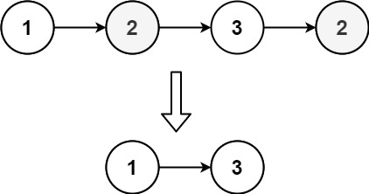

**Input:** head = [1,2,3,2]

**Output:** [1,3]

**Explanation:** 2 appears twice in the linked list, so all 2's should be deleted. After deleting all 2's, we are left with [1,3].

**Example 2:**

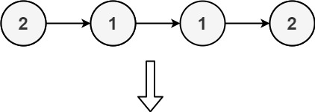

**Input:** head = [2,1,1,2]

**Output:** []

**Explanation:** 2 and 1 both appear twice. All the elements should be deleted.

**Example 3:**

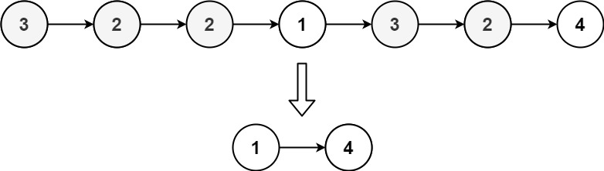

**Input:** head = [3,2,2,1,3,2,4]

**Output:** [1,4]

**Explanation:** 3 appears twice and 2 appears three times. After deleting all 3's and 2's, we are left with [1,4].

**Constraints:**

* The number of nodes in the list is in the range [1, 105]
* 1 <= Node.val <= 105